Press Release
CONTACT: FOR IMMEDIATE RELEASE
Teresa Mills Sarah Ettman-Sterner
Santa Ynez Valley Historical Museum Marketing Communications Director
(805) 688-7889 (805) 448-0946
teresa@santaynezmuseum.org nuvigreen@gmail.com
Photos are available

Come “Horse Around” with Dr. Seuss and Santa Ynez Valley Historical Museum
At the Annual Read Across America “Eggstravaganza,” March 7, 1 - 4 PM
Featuring New NY Times #1 Bestseller, Dr. Seuss’s Horse Museum!

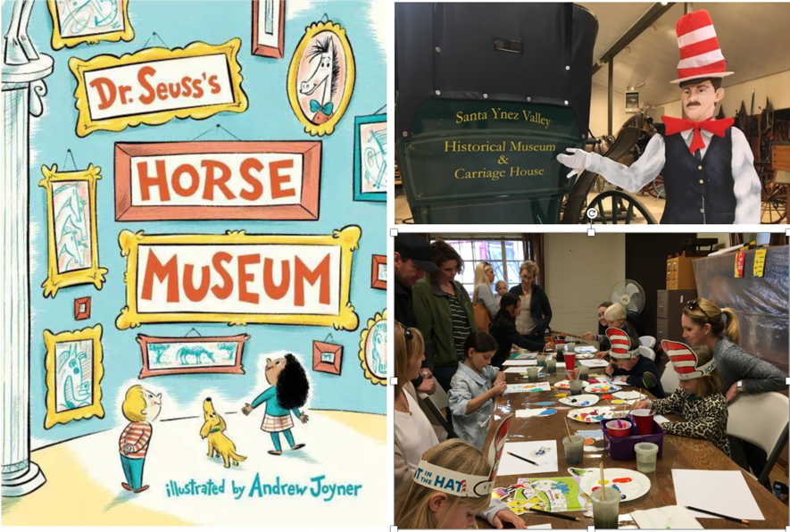

Museum to unveil never-before-published Dr. Seuss non-fiction book about creating and looking at art, along with fun activities for the whole family!

(Santa Ynez, CA, January 31, 2020) –Theodor Seuss Geisel, a.k.a. Dr. Seuss, once said, “A person’s a person, no matter how small. Children want the same things we want. To laugh, to be challenged, to be entertained and delighted.” His work has influenced generations and children of all ages to find joy in reading books. The Santa Ynez Valley Historical Museum is pleased to announce that the spirit of Dr. Seuss will once again come alive during their annual Read Across America “Eggstravaganza.” The
family -friendly event for all ages will be presented in collaboration with the Santa Ynez Valley Libraries, is free and open to the public. It takes place on March 7, from 1:00 to 4:00 PM at the Museum, located at 3596 Sagunto Street, Santa Ynez, CA. What makes this a very special experience is that it will feature a read-aloud of Dr. Seuss’s Horse Museum! a new, New York Times Bestseller, illustrated by Andrew Joyner.

Dr. Seuss fans will be treated to activities with thematic elements from the book. Guest poets, artists, and entertainers will be on hand to provide creative opportunities for kids. Participants will enjoy making their own "Seussically-inspired" artwork. Dr. Seuss-themed snacks will be served such as “Go Dog Go” hot dogs, green deviled eggs, and more. A variety of books about horses will raffled off during the event to raise fund for the Museum’s education programs. In addition, visitors can view horse-themed artwork and exhibits which complement the story in Dr. Seuss’s Horse Museum. The Museum’s Parks-Janeway Carriage House will be open, showcasing some of the finest examples of horse-drawn transportation west of the Mississippi. Equine enthusiasts can also learn about antique saddles and tack used by Valley Vaqueros and cowboys for riding and caring for their horses. In addition, the historic Santa Ynez Branch Library, established in 1910 and located next door to the Museum, will be open for touring.

Theresa Reilly, SYVHM Curator of Education says, “Dr. Seuss’s Horse Museum is the perfect book choice for this year’s Read Across America “Eggstravaganza.” A never-before-published Dr. Seuss non-fiction book about creating and looking at art is based on an unrhymed manuscript and sketches discovered in 2013. This book is like a visit to a museum—with a horse as your guide, with guest appearances by the Cat in the Hat, The Grinch and Horton the Elephant. It’s silly, and playful while stimulating critical thinking about creating art with the horse as an artist’s muse. What could be better than the magic of a hot-off-the-press Seuss-themed story, introduced to a whole new generation of Valley children in a Museum that celebrates the role horses have and still play in our region? We hope the day will inspire young readers to embrace reading and value the Museum as a place to learn, have fun and grow.”

The Museum is calling for extra volunteers who are needed to read books, help with art projects, perform, and display children’s art and poetry. If you would like to help, please contact Ms. Reilly at
education@santaynezmuseum.org, or call (805) 688-7889, extension XXX.

###

About SYVHM

Founded in 1961, the mission of the Santa Ynez Valley Historical Museum and Parks-Janeway Carriage House is “Preserving, interpreting and celebrating the history of human experience in California’s Santa Ynez Valley and Central Coast by informing, educating, inspiring and engaging Museum guests of all ages and backgrounds.” The Museum is the official caretaker of the Valley’s rich cultural history, housing one of the finest collections of antique, horse-drawn carriages and wagons in the Western United States, examples of finely crafted Chumash and other Native American basketry, pottery and artifacts, one-of-a-kind horse saddlery and tack from days gone by and Western sculptures, paintings, books and handicrafts. As the “hub” for social gatherings in the Valley, the Museum sponsors events and celebrations throughout the year including gallery openings, Festival of the Vines, Vaquero Gala, Show and Sale, Wild West Camp and educational tours for children and food and wine tastings that highlight the economic importance of the wine and agricultural industries in shaping the Valley’s future. To learn more, visit and become a member, visit www.santaynezmuseum.org.

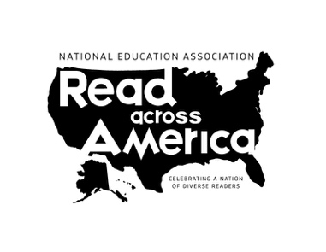
Read Across America is an initiative on reading created by the National Education Association that began in 1997. One part of the project is National Read Across America Day, an observance in the United States held on the school day closest to March 2, the birthday of Dr. Seuss. To learn more, visit readacrossamerica.org.

